Installing Web-based Administration

Windows Media Services Administrator for the Web is a complete Web site that is hosted on your Windows Media server by Microsoft Internet Information Services (IIS). You can add Windows Media Services Administrator for the Web during installation or at any time by using Server Manager. After you install Windows Media Services Administrator for the Web, you should configure an appropriate level of security for the administration Web site to protect data transferred between a remote computer and your Windows Media server. This will also help protect your network from unauthorized access. For more information, see Securing the Windows Media Administration site.
After you have installed Windows Media Services Administrator for the Web, configured the appropriate security settings, and started the Web site, you can access the Web site from any browser that supports Active Server Pages (ASP). Windows Media Services Administrator for the Web is useful if you want to administer one or more Windows Media servers from a single location or if physical or network access to the server is difficult, such as when you administer a server across a network firewall. Windows Media Services Administrator for the Web is also useful for use in temporary remote locations. For example, you can use Windows Media Services Administrator for the Web to control a broadcast publishing point from a remote location where you are producing and encoding a live event.

How To Install Webmin with SSL on Ubuntu 14.04

Introduction
Webmin is a web-based system administration tool for Unix-like systems. It provides an easy alternative to command line system administration and can be used to manage various aspects of a system, such as users and services, through the use of the provided Webmin modules. If you want to manage your own server but you are uncomfortable with the command line, Webmin is a good tool to help you get started.
This tutorial covers the installation of Webmin with SSL using apt-get on Ubuntu 14.04.

Prerequisites
To install Webmin, you will need to have access to a user with root privileges. It is recommended that you set up a non-root user with sudo access by following steps 1-3 of this link: Initial Server Setup with Ubuntu 14.04. This user will also be used to login to the Webmin interface, and Webmin will use the credentials to administer your server.
Note that you are required to use password-based authentication enabled to log in to your server via Webmin.

Log in Via SSH
Log in to your server as the new user that you created (or root) via SSH (substitute your user name and server IP address here):
ssh new_user@server_IP_address
Answer the password prompt to complete the login process.
Let's get started with the Webmin installation!

Install Webmin
To install Webmin via apt-get, you must first add the Webmin repository to your sources.list file.
On your server, open the sources.list file in your favorite text editor. We will use nano in this tutorial:
sudo nano /etc/apt/sources.list
If you are prompted for a "[sudo] password", enter your user's password.
Now press Ctrl-W then Ctrl-V to navigate to the end of the file, then add the following lines to the file:
deb http://download.webmin.com/download/repository sarge contrib
deb http://webmin.mirror.somersettechsolutions.co.uk/repository sarge contrib
When you are finished editing, save the file by pressing Ctrl-X, then y, RETURN.
Now add the Webmin GPG key to apt, so the source repository you added will be trusted. This command will do that:
wget -q http://www.webmin.com/jcameron-key.asc -O- | sudo apt-key add -
Before installing Webmin, you must update apt-get's package lists:
sudo apt-get update
Now run this apt-get command to install Webmin:
sudo apt-get install webmin
Enter y to confirm the installation.
After the installation is complete, the Webmin service will start automatically.

Log in to Webmin
In a web browser, access your server's Webmin login page via its public IP address (the same IP address you used to login via SSH) on port 10000. By default, Webmin will start with SSL/TLS enabled, so you will need to use HTTPS to connect to it.
Open this URL in your web browser (substitute the IP address):
https://server_IP_address:10000
You will be prompted with a warning that says your server's SSL certificate is not trusted. This is because Webmin automatically generates and installs an SSL certificate upon installation, and this SSL certificate was not issued by a certificate authority that is trusted by your computer. Although your computer cannot verify the validity of the certificate, you know that you are, in fact, accessing your own server. It is fine to proceed.
Instruct your web browser to trust the certificate. If you are using Chrome, for example, click the Advanced link, then click the Proceed to server_IP_address (unsafe) link. If you are using Firefox, click I Understand the Risks, then the Add Exception... button, then the Confirm Security Exception button.

At this point, you will see the Webmin login screen:
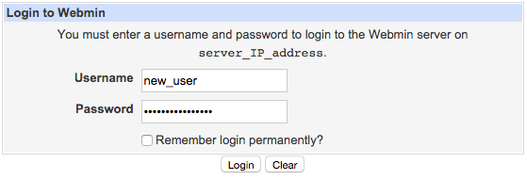
Enter the same login credentials that you used to log in to your server via SSH. This user must have root privileges via sudo.
Congratulations! You have successfully installed Webmin, and it is ready to be used. Remember that, because you are using a privileged user to access Webmin, the Webmin application has full access to your server—keep your login credentials secure!

Using Webmin
When you first log into Webmin, you will be taken to the System Information page, which will show you an overview of your system's resources and other miscellaneous information. This view also shows you any Webmin updates that are available.

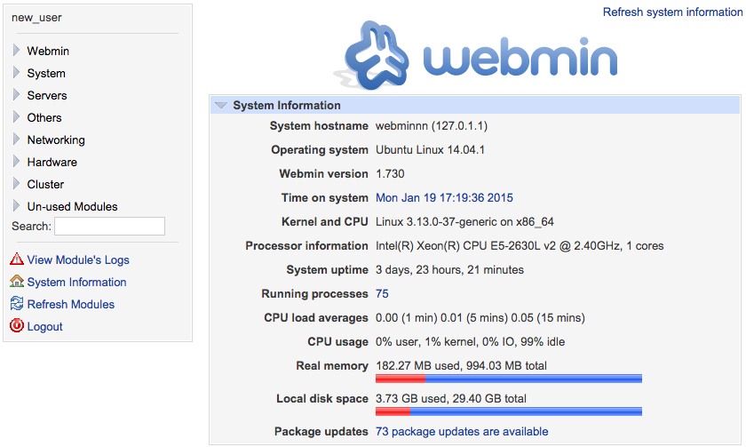

On the left side, you will see the navigation menu, which you can use to access the various Webmin modules and manage your server. The navigation menu is organized into categories, and each category has its own set of modules. The Webmin category is special because contains modules that are used to configure the Webmin application, while the other categories are used to perform various system administration tasks.
Take some time to explore the modules that are available, to familiarize yourself with Webmin.

Example: Create a New User
A basic system administration task that you can perform with Webmin is user management. We will show you how to create a new user with the Users and Groups module.
Expand the System category in the navigation menu, then click on Users and Groups.
Then click the Create a new user. link.
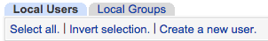
Enter the Username and any other settings you want to assign to the new user, then click the Create button.
The user will be created on the server, with the specified settings.
The Users and Groups module can also be used to perform other user management tasks, such as deleting and disabling users and groups.

Example: Install Apache
Webmin comes with a large variety of modules that manage different software packages. We will demonstrate how to install a web server using the the Apache Webserver module, as an example.
In the navigation menu, click Un-used Modules to expand the category, and then click Apache Webserver.
If you do not have Apache installed on your server, the module will notify you and provide you with a way to install Apache.
Use the Click here link (in the last sentence) to install Apache via apt-get through Webmin.
After the Apache installation is complete, your server will be running the default Apache server.
The Apache Webserver module will be moved to the Servers category, and you may use it to manage the configuration of your Apache server.

Remote Administration with Linux
The next best thing to being there is being able to log into your systems remotely. One of the great things about Linux is the variety of tools you can use to remotely administer your Linux desktop and server systems. From the command line to GUI tools, you can take control of it all right from the comfort of your very own desktop anywhere you happen to be.
I'm going to introduce you to three ways you can remotely administer your desktops and servers: Secure Shell (SSH), Remote Desktop Viewer, and TeamViewer. Once you've completed this article, it will be up to you to decide which method best suits your needs and when.

Secure Shell
This is, by far, the fastest and easiest method of remotely administering your desktop. Gaining remote access from one machine to another is simple and secure with SSH. You issue the ssh command from your local machine to connect to your remote machine and you can begin to run commands to remotely administer that machine. Typically, the command to connect to a remote machine will look like this:
ssh -v -l usernameremote-host
Where username is the username you want to connect with and remote-host is the IP address or fully qualified domain name (FQDN) of the remote machine you want to access. Once you have successfully connected you will find yourself at the bash prompt of the remote machine. Start firing away commands.
But what if you want (or need) to use GUI tools this way? You can. SSH has the capability of tunneling X protocols built in. This means you can run the GUI tools on the remote machine on your local machine. Why would you want to do this over remotely connecting to the desktop via VNC or Team Viewer? By only using the GUI tools you need you are not slowing down the administrative process by having to process an entire desktop via the network. It's one tool at a time.
To do this the ssh command looks like:

ssh -v -l usernameremote-host –X

That's it. Just add the -X switch and SSH will now tunnel X Windows. You can start up the GUI tools you need by simply executing the commands to start them up. This will, of course, require you to know the commands for the tools.
One word of warning. It may be tempting to allow root user connections to the SSH daemon. Do not allow this. Secure shell in as a normal user and then su to root if you need to work as root on a system remotely. Allowing root connections via SSH is inviting trouble. To make sure you do not allow SSH root connections look at the /etc/ssh/sshd_config file and make sure the line PermitRootLogin yesis commented out (it is preceded by a # symbol), or simply change it to no instead. If you have to make this change then restart the ssh daemon after you save the file.

Remote Desktop Viewer
Remote Desktop Viewer is a different beast. With this tool you are going to be administering using the remote machines complete desktop. For these types of connections to work the remote machine must have a server running allowing connections to be made. Fortunately this is very simple. And fortunately the necessary tools are installed by default in the more recent GNOME desktops. Let's first take a look at how this is set up.

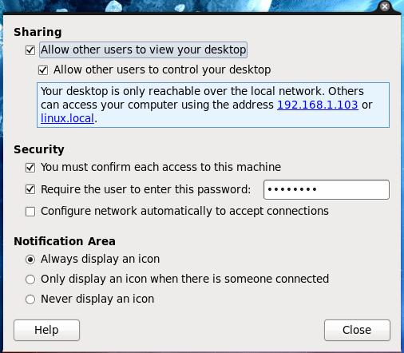

The first step is to allow connections to be made on the remote machine. To do this click System > Preferences > Remote Desktop. This will bring up a small window (see Figure 1) where you configure allowed connections. You want to take care of this set up as a poorly configured server could allow anyone onto your desktop.
Take note of the address you are given for remote connections. Also make sure you select either (or both) options "You must confirm each access to this machine" and/or "Require the user to enter this password". If you are going to be doing the remote administration you will not want to enable the former as you will not be there to confirm.

Once you have this configured click close and you are ready to connect.
To connect to this machine click Applications > Internet > Remote Desktop Viewer. This will bring up a small window that allows you to manage your remote connections.

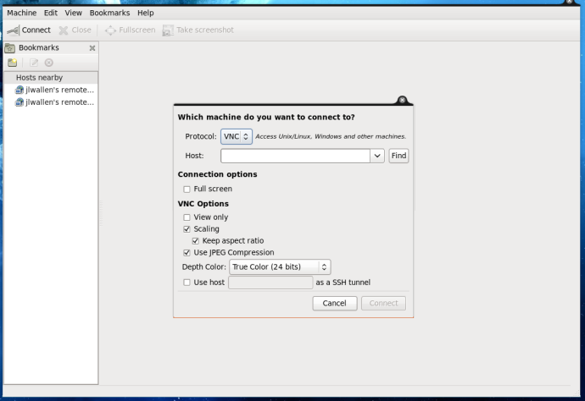

The first thing you need to do is click the Connect button. This will bring up a small window (see Figure 2) that allows you to enter the connection properties for the remote connection. This is fairly straight-forward: Just fill in all the pieces and click Connect. Once you are connected you will have complete control over the remote desktop. If you do not set this connection up to do Full Screen your remote session will remain in the Remote Desktop Viewer window (right pane). You can maximize that window to see the remote desktop better if you like.
Once you are done with your administration, click Close and the connection will be broken.

Team Viewer
This is yet another approach to the remote administration. This does work somewhat similarly to Remote Desktop Viewer in that it allows you full control over the remote desktop. However, where this differs is it allows you to connect to a machine that does not have to have a server installed. What I use this tool for is allowing me to do remote help sessions for other users. All they have to do is either install Team Viewer or just run the tool (from the download), give me their ID Number and Password (which I then enter it into my Team Viewer window) and we are connected.
To be the administrator you do have to install Team Viewer. To do this go to the Team Viewer home page and then click the Start Full Version It's Free button. You will then be taken to the download page. Click the Linux button and then download the file that suits your distribution. Once done you can double click that file and your Package Installer should open for installation. Or, if you are using Firefox, as soon as you click on that file to download it should open up your package installer immediately.

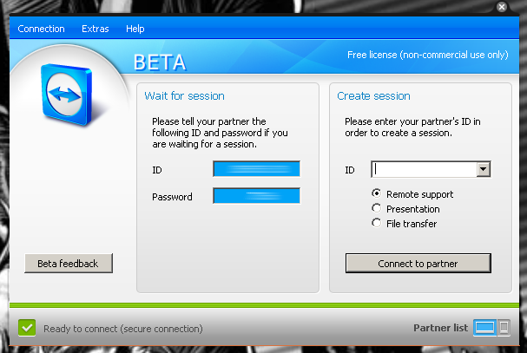
To start up Team Viewer click Applications > Internet > Team Viewer. When the application starts up you will see one simple window (see Figure 3). In this window you will see your ID and Password. When you get the ID from the remote user enter it in ID text area under the Create Session section. Once you hit enter you will then be prompted for that users' password. Enter that and you will be connected. Time for you to do your administrative thing.

